
Monthly Indicator of Economic Growth (MIEG)
August 2025

November 19th, 2025

The headline MIEG for August 2025 is 5.1%

The Monthly Indicator of Economic Growth (MIEG) is a volume index which captures changes in economic activity on a monthly basis. The MIEG is published at an aggregate level for the whole economy, as well as for agriculture, industry and services.

The MIEG for August 2025 is provisional and subject to revision when more comprehensive and updated data becomes available.

- MIEG August 2025

The MIEG index for August 2025 is 108.0. This compares to an index of 102.7 in August 2024. The yearly growth rate of the index is 5.1 percent. The index growth rate from month to month is not reported as the index is not seasonally adjusted.

Table 1: MIEG August 2025

Month | Index Level | Change Rate (%)
Month | 2023=100 | Yearly
August 2024 | 102.7
August 2025 | 108.0** | 5.1%
Provisional (**)

Note: the growth rate is calculated on non-rounded figures

We also report MIEG estimates for agriculture, industry, and services. The MIEG for agriculture grew by 7.4 percent, the MIEG for industry contracted by -1.8 percent, and the MIEG for services grew by 9.6 percent.

Figure 1: MIEG for the broad sectors

The services sector was the main contributor to August 2025 growth. The sector contributed 4.08
percentage points to the overall growth of 5.1 percent. Agriculture contributed 1.39 percentage points and Industry contributed -0.62 percentage points to overall growth of 5.1 percent.

Figure 2: Contributions to growth (p.p.)

The MIEG for agriculture increased by 7.4 percent between August 2024 and August 2025. This was driven by crop production and fish catch.

Figure 3: Agriculture MIEG
Note: 2023=100, Agriculture is highly seasonal, Y-axis starts at 50.

The Industry MIEG recorded a decrease of -1.8 percent between August 2024 and August 2025. Although the indicator for gold production increased, this was outweighed by falling petroleum output and manufacturing activity.

Figure 4: Industry MIEG
Note: 2023=100

The Services MIEG grew by 9.6 percent between August 2024 and August 2025. This expansion in activity was driven by Information & Communication, Education, Wholesale & Retail Trade, and Transport & Storage.
Figure 5: Services MIEG
Note: 2023=100

- MIEG Methodology

The MIEG covers all the economic activities contained in the quarterly GDP system. We collect monthly volume indicators and administrative records to compile growth indicators for each economic activity. The indicators are deflated using monthly Consumer Price Index (CPI) and Producer Price Index (PPI) to remove the effects of inflation.

The indicators that are used in the MIEG are the same indicators as in the quarterly GDP system as far as possible. This ensures that the growth rates of the MIEG align with the real quarterly GDP growth rates. Hence, the MIEG gives users a reliable early indication of movements in economic activity before the quarterly release. It also allows users to see the percentage contribution to the total growth from the main sectors.

To read about the full methodology and data sources used please refer to the MIEG Technical Manual on our website.

For a less comprehensive but user-friendly guide on how to interpret and understand the MIEG, please refer to the User Guide for MIEG on our website.

The publication bulletin in Excel format is available on our website, and the release is available for download on the GSS Statsbank.
- Revisions Policy

The MIEG is subject to the same revisions policy as the quarterly and annual national accounts. This means that the indicator is open for revision for up to two years. The main causes of revision are:
- Incorporation of additional and improved data. Most revisions reflect the incorporation of a wider range of data. Some data that was not available at the release date are incorporated through revisions into subsequent releases.
- Reconciliation of the MIEG with the quarterly and annual accounts. The process of reconciling the quarterly measures with the annual measures can lead to further revisions. The quarterly measures of these series are based on a smaller range of data than the annual measures.

- Notes

The MIEG is subject to continuous improvement. For example, future releases will include a breakdown of additional sub-sectors, and the time series will be expanded.

The MIEG is a non-seasonally adjusted (NSA) series. As such only annual changes are calculated from the volume index. The index does not allow for month-on-month growth rates because they could be influenced by seasonality, such as public holidays. Once the time series is long enough (at least five years) we will start publishing seasonal adjusted time series.

- Next release

We will release the indicator within 75 days of the end of the reference month. The next release will be on December 10th for the September MIEG and Q3 GDP estimates.

- MIEG Index
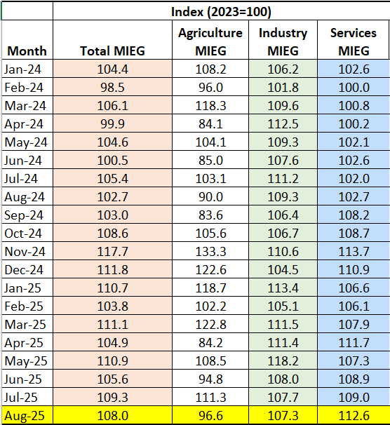

- MIEG Growth rates
